POLICIES AND PROCEDURES OF THE EXECUTIVE BRANCH

2024-2025

Michael Barcal

Student Body President
Ashlyn Davidson
Student Body Vice President

Enacted May 15th, 2024
Revised May 15th, 2024

Communication within the Council
Table of Contents
I. Preamble 3
II. Purpose 3
III. Composition of the Branch 3
IV. Membership and Responsibilities 4
A. Membership Requirements 4
B. Appointment Procedures 5
V. Duties and Powers of the Executive Branch 6
A. President 6
B. Vice President 7
C. Executive Cabinet 7
D. Executive Staff 9
E. Executive Agencies 10
VI. Workplace Standards 11
A. Definitions 11
B. Attendance Policy 12
C. Time Sheets 12
D. Reports 15
E. Meetings 15
F. Dress Code 16
G. Conduct 16
H. Harassment/Discrimination Policy 17
I. Online and Social Media Etiquette 17
J. Confidentiality 18
K. Transition Binders 18
VII. Enforcement 19
A. Internal Disciplinary Process 19
B. Grounds for Removal 24
C. Removal 24
VIII. Amendments to the Executive Branch Policies and Procedures 24
A. Authority on Amendments 25

I. Preamble
We, the elected or appointed members of the Executive Branch, in order that we may maintain and perpetuate the ideals and successes of the Student Body through an open and transparent government, and which every student may be offered equal opportunity in the purview of Student Government influence by establishing a more uniform and professional connection between the Student Body, Faculty, and Administration, do hereby ordain and establish the Policies and Procedures of the Executive Branch.

II. Purpose
The purpose of the Executive Branch shall be to represent student concerns and needs in University-wide matters through the development and promotion of programs and activities on the campus. The collective purpose of the branch includes the following:
- To be the administrative arm of Student Government.
- To research and develop programs for the advancement of cultures, clubs, organizations, and the individual student on campus.
- To provide guidance and advice to any student on any matters within the purview of Student Government.
- To uphold and enforce the Constitution and Statutes of Student Government.
- Be responsible for researching and developing programs that enhance the safety, education, welfare, and involvement of the Student Body.

III. Composition of the Branch
- The Executive Branch shall contain the positions and agencies:
  - The Student Body President
  - The Student Body Vice President
  - The Executive Cabinet, which shall contain:
    - The Attorney General
    - The Student Advocate
    - The Treasurer
  - The Executive Staff, which shall contain:
    - The Chief of Staff
    - The Deputy Chief of Staff
    - The Director of External Affairs
    - The Director of Public Relations
    - The Director of Graphic Design
  - Executive Agency Members
    - The Osprey Involvement Center Agency
      - The Director
      - The Assistant Director of Clubs
      - The Marketing Coordinator
      - The Involvement Coordinator(s)
    - The Osprey Student Conduct Advisors Agency
      - The Director
      - The Assistant Director
    - The Lend-A-Wing Agency
      - The Director
      - The Assistant Director
      - The Lend-A-Wing & Lend-A-Fit Coordinator(s)
      - The Marketing Coordinator

IV. Membership and Responsibilities

Membership Requirements
- Every Executive Branch member must be an Activity and Service (A&S) Fee paying student, enrolled in at least one class during the Fall semester and at least one class during the Spring semester at the University of North Florida, maintain an institutional grade point average of 2.5 or higher (unless otherwise approved by the Chief Student Affairs Officer), and not be restricted from participation in Student Government by the University of North Florida Student Conduct Office. Additionally, members may serve during the Summer semester without being enrolled in a class as long as they are still considered students by the University of North Florida.

Appointment Procedures
- President
  - The President shall be elected for a term of one year, and shall be limited to a maximum of two terms.
  - If a vacancy occurs in the office of the President, the Vice President shall assume office for the remainder of the term.
  - If a vacancy occurs in the office of both the President and Vice President, then the Senate President shall assume the office of the President.
  - The President may also add a newly created position to the Executive Branch, but must do so by notifying the Senate President through an Executive Order within five business days of its creation.
- Student Body Vice President
  - The Vice President shall be elected for a term of one year, and shall be limited to a maximum of two terms.
  - If a vacancy occurs in the office of the Vice President, the President shall have the power to appoint a new Vice President, subject to majority approval from Senate.
- Executive Cabinet
  - The President shall have the sole power to appoint all the officers of the Executive Cabinet. The appointed officer will then be forwarded for clearance from the Rules and Oversight Committee and majority approval from Senate.
  - The President must also report any Acting Executive Branch Cabinet Member’s first official day of work to the Senate President.
  - The position of Treasurer must be filled within the first month of the President taking office. An extension may be filed for approval to the Senate President for an additional thirty (30) days.
- Executive Staff
  - The Executive Staff are appointed by the President, and are not subject to confirmation by the Senate.
- Executive Agencies
  - The Vice President shall oversee the Executive Agencies in conjunction with the President in accordance with Title III 302.6A.
  - Directors and Assistant Directors of the Executive Agencies shall be selected by the President, or desegnee.
  - In the event there is a vacancy in the office of the Director, the Assistant Director should assume their duties on an interim basis.
  - Executive Agencies may be established by the Student Body President, with the head of each agency to be appointed by the Student Body President.

V. Duties and Powers of the Executive Branch

President
- The President shall:
  - Be the chief executive of Student Government;
  - Administer and enforce all laws of Student Government;
  - Co-sign, along with the Student Government Director, or designee, on all expenditures from Executive Branch indexes;

  - Call and preside over executive meetings of Student Government and student assemblies when appropriate;
  - Oversee executive agency operations;
  - Address the Student Body using the most popular form of communication regularly throughout their term;
  - Must establish the Executive Policies and Procedures prior to the first day of classes of the fall semester; and
  - If a new Executive Branch position is created, the President must notify the Senate President through an Executive Order within five (5) business days.

  - Additional powers of the President include:
    - Serve as a member of the University of North Florida Board of Trustees: Article IX; Section 7(C) of the Florida State Constitution;
    - Serve on the Florida Student Association;
    - Appoint individuals to University-wide Committees (UWC);
    - Serve on, or appoint a designee, to the Space Committee and the Student Affairs Community Council;
    - Serve as an Ex-Officio member of the UNF Foundation Board following confirmation of the board;
    - Serve as an Ex-Officio member of the Alumni Association Board;
    - Appoint or serve as the Student Body President Designee for the UNF Museum of Contemporary Arts Student Trustee;
    - Enforce disciplinary action regarding any violations of the Executive Branch Policies and Procedures; and
    - Issue Executive Orders to implement a Student Government entity, suspension, or permanent removal that should take perpetuity in such time that the Executive Order is repealed or found in violation of the Constitution & Statues by the Judicial Branch.

Vice President
- The Vice President shall:
  - Assume the duties of the President in their absence under extreme circumstances, such as physical incapacitation, which make it impossible to discharge the duties of the office, or at the President’s request.

  - Additional Powers of the Vice President include:
    - Shall oversee the Executive Agencies in conjunction with the President as defined by law or Executive Branch Policies & Procedures;
    - Coordinate alongside the efforts of the Cabinet and assist in the formation of Cabinet projects;
    - Coordinate with the Student Body President, Student Body Treasurer, and the Executive Cabinet to accomplish executive projects;
    - Direct grievances and ideas to the proper functionary and see that the grievances and ideas are acted upon;
    - Meet at least once a month with the Directors of Executive Agencies and affiliated projects to review performance, address questions and/or concerns, receive feedback and/or advice on the functioning of the Executive Branch, and discuss possibilities of new projects; and
    - Oversee Executive Agency staff and manage Executive Agency operations and is responsible for reporting its current affairs to the President, Executive Cabinet, and Senate when appropriate.

Executive Cabinet
- The entirety of the Executive Cabinet shall:
  - Advise the President and Vice President on general matters and to assist in the coordination of the Executive Branch;

  - Report directly to the President;
  - Submit weekly reports to the President unless otherwise notified; and
  - Not issue any binding resolution or act outside the purview of their positions as prescribed by the Constitution in Article III and Title III.
- The Treasurer Shall:
  - Serve as the executive liaison to the Student Body on all matters pertaining to A&S Fee procedures;
  - Work with the Senate Budget and Allocation Committee as a fiscal advisor, Student Government Accountant, and Student Government Business Manager in monitoring all A&S Fee accounts and advising all A&S Fee requesters on proper procedure and regulations;
  - Enforce all fiscal policies of Student Government, in the provisionary language of the current year’s A&S Fee Budget, and in the Policies and Procedures established and enacted by the Senate;
  - Periodically check the A&S Fee accounts to correlate with language and expenditures set by the current year’s budget;
  - Submit a proposed balanced A&S Fee Budget during the Annual Budget Process;
  - Assist the Business and Accounting Office in facilitating the procedural workshops for funded departments and agencies;
  - Inform the B&A Committee of all transfers;
  - Assist the Accounting Associate and Business Manager in auditing all A&S Fee accounts; and
  - Report all A&S Fee account errors, inappropriate expenditures, and other activities that are in violation of state, local, or Student Government rules or regulations to the B&A Committee and Senate.
- The Attorney General shall:
  - Be the Chief Executive Prosecutor for Student Government and as such shall serve to represent the interests of the Student Body at Large in all Student Government legal proceedings;
  - Be responsible for maintaining compliance by advising both Student Government officials and the Student Body on their rights and limits within the purview of Student Government;
  - Be responsible for periodically reviewing the Constitution and Statutes for mistakes, conflicts, or contradictions. Any such resulting revisions shall be submitted to the Rules and Oversight committee;
  - Work with and advise the Supervisor of Elections on identifying Election Code violations;
  - Act as a Chief Prosecutor on all allegations of Election Code violations; and
  - Be responsible for issuing, upon the receipt of a written request by any member of the Student Body, an interpretation of any question relating to the Student Government Constitution, System of Statutes, or subsequent Policies and Procedures within fifteen (15) business days. The Attorney General’s interpretation shall be considered binding unless negated upon Judicial Review. All interpretations issued by the Attorney General shall be reviewed by the Judicial Branch within five (5) business days.
- The Student Advocate shall:
  - Be responsible for representing the interests of the Student Body to the faculty and administration on all major academic-related programs or initiatives;
  - Serve as a liaison through Student Government to assist students with problems, concerns, and complaints, such as those involving academics and the administration, through informal means such as counseling, negotiation, and mediation; and
  - Serve as the Chief Public Defender barring a conflict of interest, and upon request, provide defense counsel to any party concerning matters under the purview of Student Government.

Executive Staff
- The entirety of the Executive Staff shall:
  - Report directly to the Chief of Staff, with the Chief of Staff reporting directly to the President; and
  - Attend events and serve at the discretion of the President.
- The Chief of Staff shall:
  - Submit weekly written reports to the President unless otherwise notified on the status of the Executive Staff’s projects and activities;
  - Oversee the daily operations and evaluate the performance of the Executive Staff; and
  - Work with the President and Executive Cabinet on projects, budgets, and initiatives as deemed necessary.
- Deputy Chief of Staff shall:
  - Submit weekly written reports to the Chief of Staff on the status of their tasks and activities;
  - Serve at the discretion of the Chief of Staff in completing necessary tasks;
  - Assist with the planning and hosting of Student Government related events;
  - Oversee general Executive Branch programming in consultation with the President, Vice President, and Chief of Staff; and
  - Assist the Executive Staff with other projects as needed at the request of the President or Chief of Staff.
- The Director of External Affairs shall:
  - Submit weekly written reports unless otherwise notified to the Chief of Staff on the status of their tasks and activities;
  - Serve as Chief Legislative Liaison for Executive Branch and maintain relationships with legislators at the local, state, and national levels.
  - Lead Executive Branch projects that focus on community engagement within the University, organizations outside of UNF Student Government, and relationships with Student Government Associations across the nation and the State of Florida.
  - Assist in boosting student and community engagement with a special emphasis on the City of Jacksonville, the State of Florida, and the Florida Student Association (FSA).
  - Assist the Executive Staff with other projects as needed at the request of the President or Chief of Staff.
- The Director of Public Relations shall:
  - Submit weekly written reports unless otherwise notified to the Chief of Staff on the status of their tasks and activities;
  - Serve as the primary spokesperson for the Executive Branch and the President, organizing press releases, working with the major student media outlet, and coordinating with other external outlets as needed;
  - Ensuring that Professional Staff and all appropriate members are advised on any external media correspondence before scheduled correspondences;
    - All external releases must be approved by the President and the UNF Marketing and Communications department;
  - Be responsible for maintaining and posting on all Student Government social media accounts and advising those of the Executive Agencies;
  - Develop and implement marketing strategies to promote the projects of Student Government;
  - Be responsible for setting up interviews with all the branches of Student Government and the major student media outlet; and
  - Assist the Executive Staff with other projects as needed at the request of the President or Chief of Staff.
- The Director of Graphic Design shall:
  - Submit weekly written reports to the Chief of Staff on the status of their projects and activities;
  - Create original graphic designs and digital media for Executive and Agency programs and projects; and
  - Assist the Executive Staff with other projects as needed at the request of the President or Chief of Staff.

Executive Agencies
- The established Executive Agencies shall be recognized as the Osprey Involvement Center, Osprey Student Conduct Advisors, and Lend-A-Wing.
- All Executive Agency Directors, Assistant Directors, and staff shall follow the duties prescribed in the Executive Agency Policies and Procedures and Constitution and Statutes (within Title XI: The Executive Agency Statute).
- The Vice President shall oversee the hiring process for Agency Directors, Assistant Director, and staff, and shall advise the President on hiring or dismissal of staff before any signatures are provided on the Executive Agency pre-employment form(s) (Title XI, 1101.3-1101.3).
- The entirety of the Executive Agency Staff shall report to their respective Agency Director, who shall report at the pleasure of the Vice President.
  - The Vice President shall oversee the current Executive Agency affairs and ensure compliance with all its staff.
  - Executive Agency Directors shall coordinate the daily operations and evaluate the performance of the Executive Agency Staff.
- The Vice President may propose the creation of an Executive Agency with express approval of Executive Order that shall be issued by the President and contingent upon Senate approval.
- The Vice President shall manage the Agency Policies and Procedures, including the RSO Handbook, and may be vested signature authority on behalf of the President.
  - The Vice President shall serve as the Presidential delegate and vested final signage authority for RSO funding.

VI. Workplace Standards

Definitions
- No Executive Branch member shall commit or allow the following, as defined below:
  - Abuse – A misuse of anything; cruelty that causes harm to another.
  - Bullying – A pattern of behavior when a person repeatedly uses power in an intentional manner, including verbal, physical, or written conduct or intentional electronic communication against another individual.
  - Defamation – The taking from one’s reputation. The offense of injuring a person’s character, fame, or reputation by false and malicious statements.
  - Discrimination – Differential treatment of a student or student group solely on the basis of their gender identity or expression, race, ethnicity, creed, color, religion, sex, age, sexual orientation, national origin, marital status, parental status, disability, and any combination thereof, or what is outlined in the University Non-Discrimination, Equal Opportunity, and Diversity Statement.
  - False Report – making a materially false statement in bad faith in the course of proceedings under Regulation 1.0040R of the University of North Florida.
  - Falsification – To counterfeit or forge; to make something false.
  - Harassment – Unwelcome conduct toward an individual based on their protected class that is sufficiently severe, persistent or pervasive as to deny or limit a student's ability to participate in or benefit from the University's educational programs or activities, or substantially interfere with or alter the conditions of employment. Harassment includes, but is not limited to, acts such as making slurs, physical assaults or threats, and intimidation, when such conduct rises to the level provided above. Please refer to the University's Sexual Misconduct and Title IX Sexual Harassment Regulation for the definition of sexual harassment, as per Regulation 1.0040R of the University of North Florida.
  - Intimidation – A threat(s) made with the purpose of compelling a student government member or members to act against their conscience, or to prohibit said member(s) from acting within the discretion of their position.
  - Retaliation – The act of inflicting physical or professional harm against a student government member in response to a decision made within the discretion of their position.
  - Sabotage – The intentional and deliberate destruction of property or the obstruction of an activity.
  - Sexual Harassment – Unwelcome sexual advances, requests for sexual favors, or other verbal, nonverbal, written, or electronic communications or physical conduct of a sexual nature that is sufficiently severe, persistent, or pervasive so as to deny or limit an individual's ability to participate in or benefit from the University's educational programs or activities, or substantially interfere with or alter the conditions of an employee's employment, as per Regulation 1.0050R of the University of North Florida.
  - Unprofessional Conduct – Immoral or dishonest and dishonourable conduct that violates a profession’s code of ethics.

Attendance Policy
- Regular and punctual attendance is expected of all Executive Branch members to ensure a productive and positive environment.
- Failure to be on time consistently will result in remediation with a direct supervisor, then if necessary, remediation with the respective advisor, or possible notification of censure.
- Failure for the President or Vice President to be on time consistently will result in remediation with the Executive Cabinet, then, if necessary, remediation with the Student Government Director, or possible notification of censure.
- If failure to be on time consistently continues, a Notification of Censure shall be issued to said Executive Branch member.

Time Sheets
- All Executive Branch members are required to accurately clock-in and clock-out at the beginning and end of their shift, as well as for breaks over fifteen minutes long.
  - Breaks include discussion with other Student Government members not pertaining to Student Government business.
- Executive Branch members must turn in their Position Accountability forms to SG Director at the end of each pay period.
- Executive Branch members must document their time worked in the Time Sheet Binder located in the Rotunda when working on the third floor of the Student Union East Building.
  - Remote work must have attached documentation of approval in the Time Sheet Binder.
- Executive Agency members must document their time worked in the Time Sheet Binder located in their respective agencies when working on the first floor of the Student Union East Building.
  - Remote work must have attached documentation of approval in the Time Sheet Binder.
- Executive Branch members must establish when they will be in the office working by designating time on their Outlook calendars. This should be noted as “Office Hours”.
- Any Student Government business that may need to be conducted outside of regular office hours must bust be approved by the President or Vice President and respective advisor.
  - Executive Cabinet and Executive Staff members should seek approval from the President and may not work outside office hours if the respective advisor does not approve.
  - Executive Agency Directors and Staff should seek approval from the Vice President and may not work outside office hours if the respective advisor does not approve.
  - Documentation such as but not limited to, agenda, itinerary, and official correspondences should also be forwarded with such request.
  - Executive Branch members should not make a request to work outside office hours for any other members, even if it as group-dynamic event.
    - Requests should be filed separately for compliance with Human Resources, time sheet regulations, and for other documentation measurements that may be deemed appropriate.
- Time sheets must be turned in accordance with the listed hours “Office Hours” on your Student Government calendar, alongside Student Government office policies, and the discretion of Professional Staff members.
- All Executive Cabinet and Staff must notify the President and respective advisor in writing if an absence of two or more days will occur in the workspace.
- All Executive Agency Directors and Staff must notify the Vice President and respective advisor in writing if an absence of two or more days will occur in the workspace.
  - Notifications of missing designated work hours should be for professional or other conflict issues.
    - Appropriate documentation or explanations should be provided in notifications of absence.
    - If personal reasons or reasons in which the member does not feel comfortable stating potential absence of work, the Student Government member is highly encouraged to notify their respective advisor.
    - Please be advised Executive Staff and Executive Agency Staff positions are held to the rights granted under At-Will employment.
      - All information regarding the right to discuss separations of employment may be found under the University of North Florida’s Human Resources Regulations & Policies (https://www.unf.edu/regulations-policies/).
      - Additional information can also be referenced within Executive Branch Policies and Procedures VII. Enforcement C. Removal.
  - No Student Government related business is to be conducted during the time of an approved request.
- All Executive Branch members must submit, in writing, a request to work remotely for any period prior to the start of the semester in order to stay in compliance with University Remote Work Agreements.
  - The President or Vice President shall require an approval from their respective advisor.
  - Any Executive Cabinet or Executive Staff member shall require an approval from the President and respective advisor.
  - Any Executive Agency Staff member shall require an approval from the Vice President and respective advisor.
  - No Student Government related business is to be conducted during the time of a request that was not approved prior.
  - If special circumstances are required in which the remote work possibility was made aware to the Executive Branch member before the possibility of a two-week period, it may be reviewed on a case-by-case basis upon receival of official correspondence.
    - This process can upwards of two to three weeks to get a Remote Work Agreement Approved
- It is expected that all Student Government related business should be conducted during business hours. The business hours are weekdays, Monday through Friday, from 8:00am to 5:00pm.
  - Executive Branch members must take at least a thirty (30) minute break for every six (6) hours worked, notated on their timesheets.
  - Executive Branch members may not clock hours when the University is closed.
  - Any responsibilities requiring business to be conducted outside of business hours shall require a request and approval from the President and respective advisor.
    - Requests require at least twenty-four (24) hours’ written notice and written approval prior.
  - Failure to comply with this policy may result in your timesheet being returned for clarification or changes.

Reports
- Weekly reports must be submitted in a Word document or PDF file attached to an email sent to the respective supervisor.
  - The templates in which weekly reports shall be submitted will be provided by the President or Vice President respective to Executive Cabinet, Executive Staff, or Executive Agency Staff jurisdiction.
  - The template may be found within the Executive Branch welcome packet, transitional materials, or other official correspondences.
- Reports should be sent on a weekly basis unless otherwise notified.
  - Weekly reports for the Executive Cabinet must be promptly submitted to the President by 5:00pm on Friday.
  - Weekly reports for the Executive Agencies must be promptly submitted to the Vice President by 4:00pm on Friday.
  - Weekly reports for the Executive Staff must be promptly submitted to the Chief of Staff by 4:00pm on Friday.
  - Weekly reports for the Chief of Staff must be promptly submitted to the President by 5:00pm on Friday.
    - The Chief of Staff, in their report, is responsible for submitting an Executive Staff report to the President.

Meetings
- The President, by written proclamation presented to the Senate President, stating a legitimate purpose, may convene, forty-eight (48) hours after the presentation, the Senate in special meeting during which only such legislative business may be transacted as is within the purview of the proclamation, or of a communication from the President, or is introduced by consent of two-thirds (2/3) of the Senate. The President’s power to convene the Senate may be prevented only upon a petition of one-half (1/2) of the Senate’s membership. The Senate’s power of prevention cannot be general in nature and must apply only to the President's respective proclamation and order to convene.
- Internal Executive Branch meetings shall be notified with proper notice via office correspondence and/or calendar invitation.
  - The President and Vice President shall meet on a frequent basis.
  - The President may call and preside over the Executive Cabinet to conduct regular meetings, at the minimum of holding one weekly meeting.
  - The Vice President may call and preside over the Executive Agencies to conduct regular meetings, at the minimum of holding one bi-weekly meeting.
  - The President and Chief of Staff shall meet on a frequent basis.
  - The Chief of Staff may call and preside over Executive Staff to conduct regular Meetings, at the minimum of holding one weekly meeting.
  - Directors of each Executive Agency have the power to conduct regular meetings as needed.
  - The Assistant Director also has the power to conduct regular meetings in the absence of the Director.

Dress Code
- Every member of the Executive Branch is expected to dress accordingly to reflect the professional atmosphere of Student Government.
  - The Executive Branch dress code may be found within the Executive Branch welcome packet, transitional materials, or other official correspondences.
- Each member should review and be in accordance with the Dress Code provided by the administration, which provides several guidelines and examples of how to dress to the administration’s standards.
- Any updates to the Dress Code will be supplied to all Executive Branch members by the President in either a physical or digital form.
- The President may construct a dress code for Executive Cabinet and Executive Staff for individual meetings/events if necessary.
- The Vice President may construct a dress code for Executive Agency Directors and Staff for individual meetings/events if necessary.

Conduct
- No Student Government member can act in a way that promotes their own personal interest over the interest of the Student Body.
- Any Student Government member that participates in any private business, professional activity, or group which would receive a personal benefit from any government action that is performed by Student Government, shall be required to abstain from voting.
- No Student Government member shall use or allow the use of Student Government property, facilities, and vehicles with total disregard for their intended use and unnecessarily shortens its expected useful lifespan.
- No officer or employee of Student Government shall aid, advise, procure, or in any way induce another to act in violation of this chapter.
- No officer or employee of Student Government shall cover up evidence or misrepresent a fact pertaining to a violation.
- No Student Government officer or employee shall in any way engage in intimidation.
- No Student Government member shall in any way engage in retaliation.
- It is the duty of every Student Government Member to hold themselves to the highest moral and ethical standards in all Student Government matters.
- No Student Government Member shall commit written, printed, or verbal defamation or purposely misrepresent any material fact(s) through their speech or actions.

Harassment/Discrimination Policy
- Reporting Discrimination/Harassment
  - Any person under the purview of Student Government who feels like they are being harassed, discriminated against, or the victim of a hostile work environment is encouraged to do any of the following:
    - Contact a responsible employee
    - Fill out a Student Government Incident Report with any responsible employee, which is defined as an individual who is required to promptly report allegations of Sexual Misconduct by or against any member of the University Community to the University’s Title IX Coordinator.
    - For help, victims can call the following numbers:
      - UNF Police Department: (904) 620-2800
      - UNF Victim Advocacy Center: (904) 620-1010
      - UNF Ethics Hotline: (844) 401-0004
      - UNF Counseling center: (904) 620-2602
  - Any student employed by Student Government, should report any cases of sexual harassment or Title IX violation they have witnessed or have been made aware of to a Responsible Employee.

Online and Social Media Etiquette
- No individual member of the Executive Branch shall:
  - Instigate, intimidate, discriminate, retaliate, or defame any individual in the purview of the Student Body or Student Government on any social media platform.
  - Leak or misrepresent information that they are not cleared to distribute.
  - Attack any individual in the purview of the Student Body or Student Government on any website or social media platform.

Confidentiality
- Members of the Executive Branch shall not:
  - Release any information about any individual in the Student Body without their consent.
  - Release any information that contains sensitive or important material, unless otherwise approved for a press release by the President and Director of Public Relations.
  - Expose any information from private meetings without the consent of the individuals that attended the meeting.

Transition Materials
- Over the course of their term, each Executive Branch member shall continuously develop transition materials on their respective positions in the Student Government files and O-Drive

  - Any personal opinions provided should be phrased in a professional manner to ensure the learning and success of the individual who is to assume your office.
  - Any conflicts and violations of the above statement may result in the loss of transition materials for your successor.
- The purpose of transition material is to pass along information about the position to the successor of that position and should include the following:
  - A template, which serves as a precise skeleton model of how a document should be written, on important documents (i.e. Purchase Requests, Room Reservations, et cetera) and emails.
  - Professional tips on the position that is based off the collective knowledge from the year.
  - An opening letter to the successor, which offers words of advice on the position, explanations, and things the individual would have liked to completed during their term.
  - A timeline, giving a rough estimate on what things should be completed by what time.
  - Basic duties and requirements for the positions.
  - A checklist to help the successor adjust to the new position.
  - Adequate examples of each important document or email.

VII. Enforcement

- Noncompliance shall be defined as the failure or refusal to comply, whether intentional or not, with the Student Government Constitution and by extent the System of Statutes, and/or any policy, procedure, Legislative act, Judicial Decision, or Executive Acts created within their bounds. An issue of noncompliance shall constitute grounds for a Judicial Complaint to be filed in the matter.

Internal Disciplinary Process
- This section shall serve as the official internal disciplinary process when there is defiance of the Executive Policies and Procedures.
- Notification of Censure:
  - “Notification of Censure” shall be a written notification which shows condemnation or disapproval of the actions or inactions of an Executive Branch member in accordance with the Executive Branch Policies and Procedures.
  - Any Executive Branch member recognized by the Constitution, Statutes, and/or Executive Policies and Procedures can be issued a Notification of Censure.
- Authority to Issue Notification of Censure:
  - The President or Vice President has the authority to issue a Notification of Censure to any Executive Branch member.
    - All Executive Branch members have the responsibility to notify the President through written documentation of any observation or knowledge of defiance from any Executive Branch member of the Executive Policies and Procedures within the Executive Branch.
    - The President shall have five (5) business days from when the defiance was brought to their attention to issue a Notification of Censure.
  - The Executive Cabinet, with unanimous consent, has the authority to issue a Notification of Censure to the President or Vice President.
    - All Executive Branch members have the responsibility to notify the Executive Cabinet through written documentation of any observation or knowledge of defiance from the President of the Executive Policies and Procedures within the Executive Branch.
    - The Executive Cabinet shall have five (5) business days from when the defiance was brought to their attention to issue a Notification of Censure.
- Form of Notification of Censure:
    - Each Notification of Censure from the President or Vice President shall be drafted in the following form (names are not listed on examples):
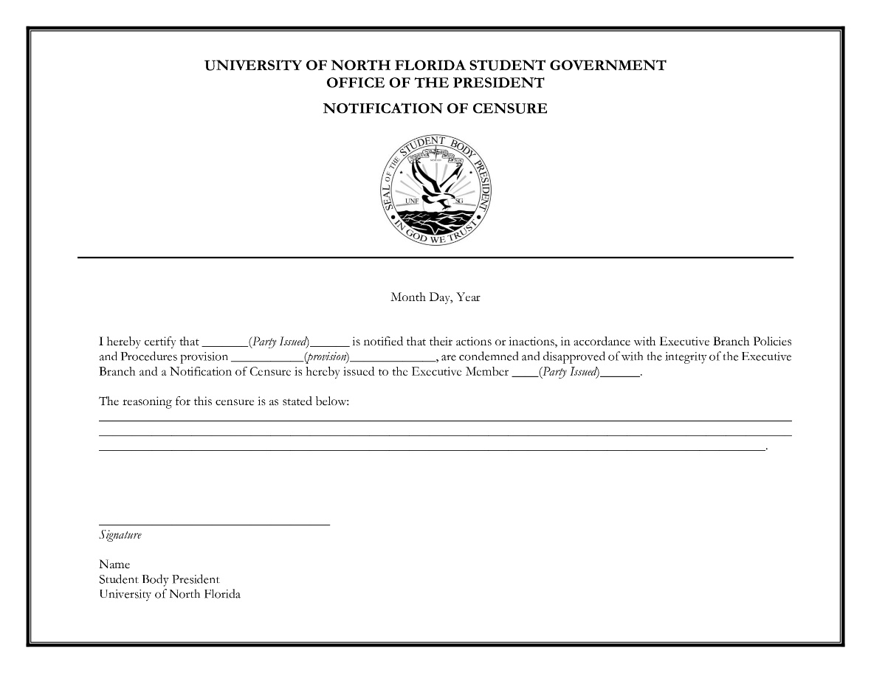
    - Each Notification of Censure from the Cabinet shall be drafted in the following form (names are not listed on examples):
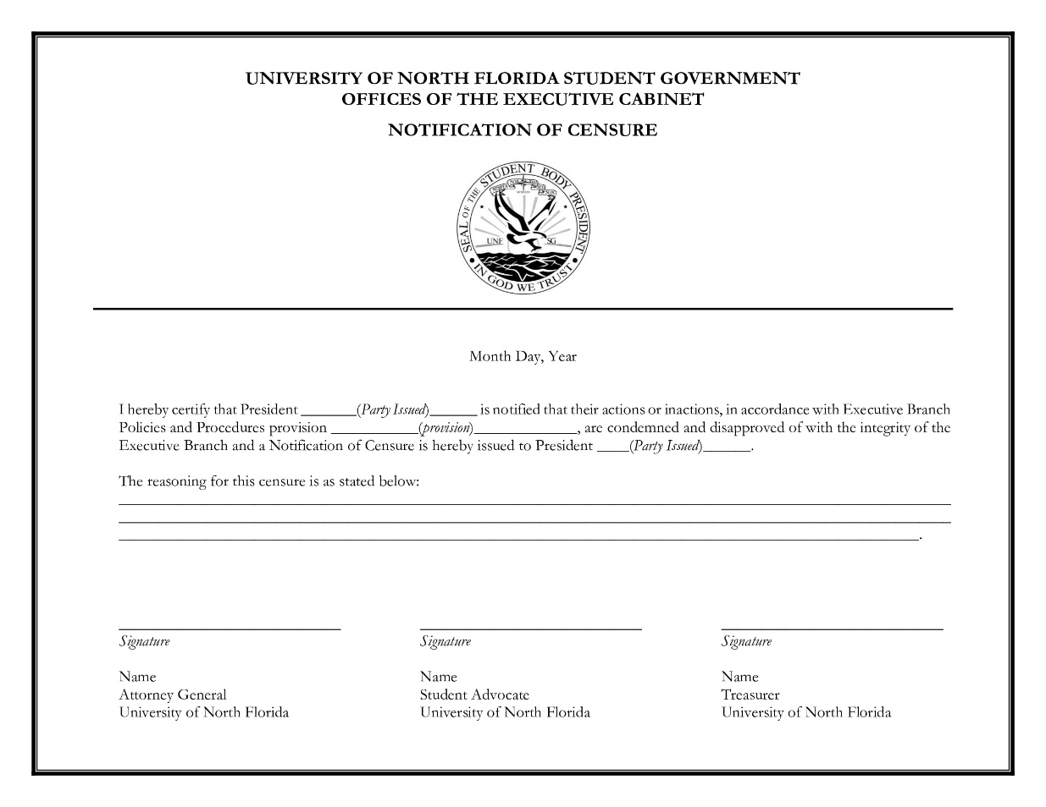

- Disposition of Notification of Censure:
  - After issuing a Notification of Censure, the issuer must deliver to the issued a digital and timestamped physical copy.
    - A copy of the Notification of Censure shall be retained for record by the issuer(s), issued, and the Attorney General.
    - If the issued in question is the Attorney General, their copy shall be retained by the Student Advocate.
    - If the issues in question is the Student Advocate, their copy shall be retained by the Student Advocate.
- Acknowledgment of Censure:
  - “Acknowledgement of Censure” shall be a written acknowledgement which shows the receipt of the physical copy of Notification of Censure.
    - The President or Vice President, when delivering a physical copy, shall have the issued and a witness from the Executive Cabinet sign an “Acknowledgement of Censure” with a timestamp.
    - The Executive Cabinet, when delivering a physical copy to the President or Vice President, shall have the President or Vice President and an additional witness from the Executive Cabinet sign an “Acknowledgement of Censure” with a timestamp.
    - Each “Acknowledgement of Censure” from the President or Vice President shall be drafted in the following form:
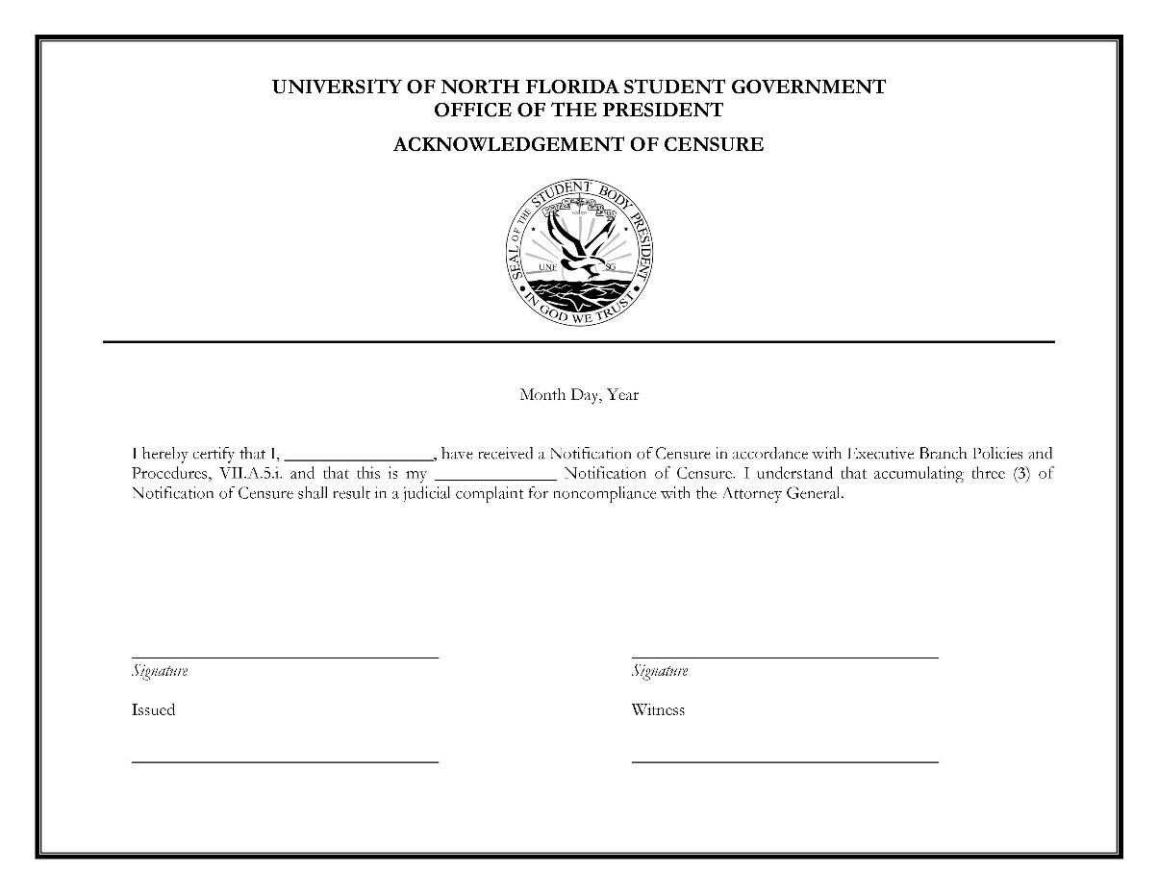

    - Each “Acknowledgement of Censure" from the Executive Cabinet shall be drafted in the following form:
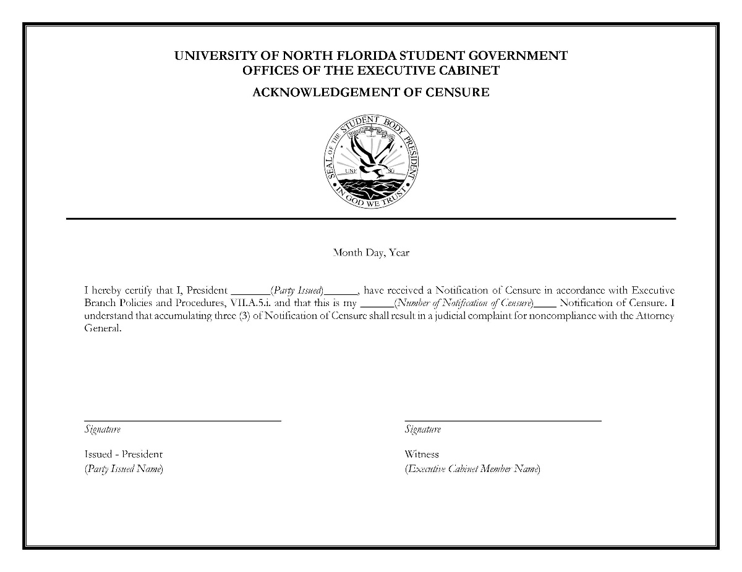

- Upon accumulation of three (3) Notifications of Censure, a judicial complaint for noncompliance shall be filed with the Attorney General, in accordance with Title VII, 700.2. and Executive Policies and Procedures, VII.1.
  - After a judicial complaint for noncompliance is filed, if said Executive Branch member receives an additional two (2) Notifications of Censure, grounds for a second judicial complaint for noncompliance shall be filed.
  - After a second judicial complaint for noncompliance is filed, if said Executive Branch member receives one (1) Notification of Censure, grounds for a judicial complaint shall be filed with the Attorney General.

B. Grounds for Removal
- Malfeasance, which shall be defined as “a wrongful, unlawful, and/or dishonest act committed” by an elected or appointed member of Student Government.
- Misfeasance, which shall be defined as “a lawful act performed in a wrongful manner” by an elected or appointed member of Student Government.
- Neglect of duty, which shall be defined as nonfeasance, is "the failure to act when a duty to act existed”.
- Incompetence, which shall be defined as “The state or fact of being unable or unqualified to do something”.
- Permanent inability to preform official duties.
- Conviction of felony within the justice system of the United States of America.

C. Removal
- The impeachment processes of an Executive Branch member are outlined in Title VII.
- Dismissal of an Executive Agency Director or Assistant Director
  - Any Agency Director or Assistant Director at any time, for any reason.
  - All Agency Staff are ultimately subject to dismissal from the President.
    - The Vice President may dismiss Agency Staff on behalf of the President
    - The Vice President may advise dismissal of any Agency Director are ultimately subject to dismissal from the President pursuant to Title XI: The Executive Agency Statue, Chapter 1101.6.
- Dismissal of Executive Staff
  - Executive Staff may be dismissed by the President at any time, for any reason.

Policies and Procedures

Authority on Amendments
- The President is solely responsible for all revisions and additions to the Executive Policies and Procedures.
- The President may make revisions and additions at any time but can only be implemented with written notice. Additionally, these changes must be made public.
- Any revision or addition to the Executive Policies and Procedures must be in accordance with the University of North Florida Constitution and Statutes, policies, as well as any state or federal laws.

So Ordered,

___________________
Michael Barcal
Student Body President
University of North Florida

