NOTICE OF AMENDED REGULATION

May 7, 2024

BOARD OF GOVERNORS
Division of Universities
University of North Florida

REGULATION TITLE:
Illicit Stormwater Discharge

REGULATION NO.:
6.0250R

SUMMARY:
The amendment to the regulation includes a minor revision to add to the definition of what constitutes an illicit discharge.

MEETING DATE:
June 13, 2024

FULL TEXT:
The full text of the regulation being proposed is attached.

AUTHORITY:
Florida Constitution, Article IX, Section 7(c) and
Florida BOG Regulation 1.001.

UNIVERSITY OFFICIAL INITIATING THE PROPOSED REVISED REGULATION:
Dan Endicott, Director Environmental Health and Safety

INDIVIDUAL TO BE CONTACTED REGARDING THE PROPOSED REVISED REGULATION:
Stephanie Howell, Paralegal, Office of the General Counsel, showell@unf.edu, phone (904)620-2828; fax (904)620-1044; Building 1, Room 2100, 1 UNF Drive, Jacksonville, FL 32224.

Any comments regarding the amendment of the regulation must be sent in writing to the contact person on or before June 6, 2024, to receive full consideration.

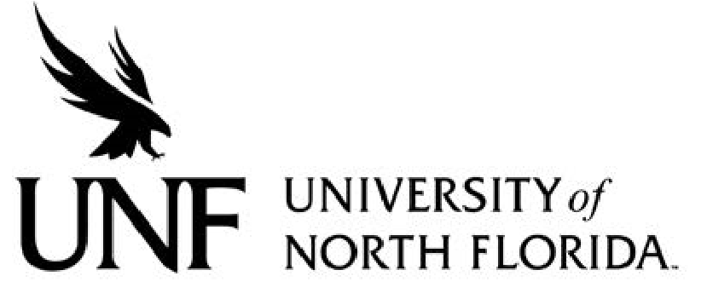 Regulation
Regulation Number: 6.0250R

Effective Date: 10/11/2018 Revised Date: 06/13/2024

Subject: Illicit Stormwater Discharge

Responsible Division/Department: Administration & Finance/Environmental Health and Safety

Check what type of Regulation this is:
☐New Regulation
☐Major Revision of Existing Regulation
☒Minor/Technical Revision of Existing Regulation
☐Reaffirmation of Existing Regulation
☐Repeal of Existing Regulation

- OBJECTIVE AND PURPOSE
The purpose of this regulation is to prohibit illicit discharges to the University of North Florida’s Municipal Separate Storm Sewer System (MS4) in compliance with Phase II of the Environmental Protection Agency’s National Pollutant Discharge Elimination System (NPDES) program.

- STATEMENT OF REGULATION
- Background
The Florida Department of Environmental Protection (DEP) regulates illicit discharges to surface waters in the state of Florida. In an effort to address this type of pollution, stormwater management regulations were established to reduce the impact of contaminated stormwater runoff from MS4s, which systems include ditches, curbs, gutters, storm sewers, and similar means of collecting or conveying runoff that do not connect with a sanitary wastewater collection system or treatment plant.
Pursuant to Florida Administrative Code Section 62-624, the University of North Florida (UNF) is required to comply with these stormwater management regulations. Accordingly, UNF is required to prohibit illicit discharges. An illicit discharge is any discharge to the UNF campus storm sewer system that is not composed entirely of stormwater, with the exceptions of State recognized exclusions or activities covered by a specific discharge permit. Examples include: run-off from construction sites, car washing in parking lots and chemical spills that enter a storm drain or retention pond.
As part of the UNF’s commitment to environmental stewardship, illicit discharges to the UNF MS4 are prohibited.

B. Roles and Responsibilities

      - UNF President:
Pursuant to UNF’s Board of Trustees’ Resolution on Presidential Authority, the President of the University has the authority, responsibility, and duty to confirm that UNF is in compliance with all applicable laws, rules, regulations, and requirements and to minimize University risk and manage the University’s risk management program.

2. Employees, Students, Contractors, and Visitors:

It is the obligation of UNF employees, students, contractors, and visitors to:
  - refrain from discharging any illicit materials into the UNF storm sewer system; and
  - report any observed illicit discharges to the Department of Environmental Health and Safety (EH&S) or the University Police Department (UPD).

3. Colleges, Departments, Units, and Contractors: It is the obligation of UNF Deans, Chairs, Directors, and contractors to:
  - take appropriate actions to ensure that illicit materials are not discharged to the UNF storm sewer system in the course of activities related to their operations or the operations of those working under their purview;
  - ensure that if an illicit discharge is discovered within a College’s, Department’s, unit’s, or contractor’s jurisdiction, it will ensure that the discharge has ceased and that appropriate measures have been taken to remediate the situation;
  - report all illicit discharges to UNF EH&S or UPD; and
  - bear the financial responsibility of remediating any environmental contamination resulting from illicit discharges related to their activities or the activities of those working under their purview.

4. Environmental Health and Safety (EH&S): It is the obligation of UNF EH&S to:
  - respond to all reports of illicit discharges and take necessary actions to mitigate releases, including procuring and directing cleanup operations, and, if required remedial actions are beyond the ability of EH&S, contact a contractor to complete the remediation;
  - notify environmental authorities, as required by law, in the event of an illicit discharge;
  - provide guidance to the UNF community regarding the prevention of illicit discharges.
Specific Authority: F.A.C. 62-624. History – new. Approved by BOT 10/11/18. Amended as approved by the BOT _____________.

